Properties of Geiger-Mueller Counting Systems

NE 312 Laboratory 3

Date Performed: March 9, 2006

Due Date: April 03, 2006

by

Shim Safety

Instructor: Dr. Shoaib Usman

Teaching Assistants: Mike Flagg and Jonathan Frasch
Abstract

The Geiger Mueller detector is one of the simplest and most economical detectors in existence. The Geiger Plateau voltage is of interest in any Geiger Mueller Counter. This plateau gives a range of voltages that allows the detector to operate properly. The proper plateau voltage is right at the beginning of the range of voltages that the detector will operate. One part of this experiment was to plot a graph of this Geiger Plateau region. Upon plotting the voltages and counts in Excel, the results yielded a similar plot that the Knoll book gave.
Two other numbers of interest are dead time and system efficiency. Dead time is the time when a detector cannot produce another pulse due to the need for the multiplication process to reverse itself through recombination. Dead time in the Geiger detectors is in the order of magnitude of hundreds of microseconds. The two-source method was used to calculate dead time. This dead time calculation method requires two radiation sources. In the process, one of the sources is counted, then the other, and finally a cumulative count of both sources is taken. These values can be placed into an algebraic expression to determine dead time. Dead time was found for the Northwood model Geiger counter to be 936 microseconds. This dead time was higher than several hundred microseconds. One main conclusion was that the sources were not intensive enough to calculate dead time correctly, since the fractional dead time was less than twenty percent. The last quantity of interest was system efficiency. Efficiency was calculated by a ratio of the counts the detector recorded over the activity of the source. Efficiency was calculated to be 0.074% for Source 1 and 0.066% for Source 2.

TABLE OF CONTENTS

1.0 Introduction 1
Figure 1.1 Radiation Detection Regions 1
Figure 1.2: Geiger Mueller Region Highlights 2
Figure 1.3: Dead Time and Recovery Time 2

2.0 Experimental Setup 3
Figure 2.1 Experimental Setup 4

3.0 Experimental Results 5
Figure 3.1 Geiger Counter Plateau Voltage 5
Table 3.1 Dead Time Calculation Parameters 6
Table 3.2 Source Efficiency Data 7

4.0 Discussion of Results 7

5.0 Conclusions 10

6.0 Reference 11

A.1 Appendix A: Raw Data…………………………………………………………………12

1.0 Introduction

The Geiger Mueller counter is one of the oldest, economical, and simplest detectors in existence for radiation detection. The Geiger counter is most commonly used to detect if a field of radiation is present. Similar to the proportional chamber, the Geiger counter uses gas multiplication to detect radiation. Normal fill gases used are argon or helium. The Geiger counter operates at a high voltage, which causes enough gas multiplication to cause the pulses to have the same height. As a result of the high voltage, the Geiger counter cannot make any distinctions in spectroscopy or radiation type.
In setting up the Geiger Mueller counter, the plateau voltage is important for constant gas multiplication. The Geiger counter must be set at a high enough voltage so that the gas will multiply to a high enough pulse height. The voltage is set in the Geiger – Mueller Region. The plateau voltage will be in an area known as the Geiger counting plateau. Figure 1.1 shows this region along with other regions.

Figure 1.1 Radiation Detection Regions
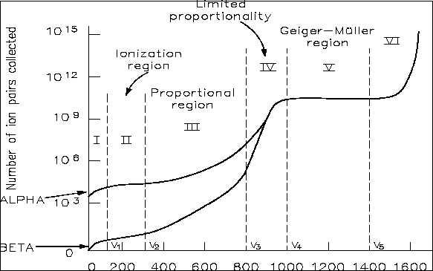

Figure 1.2 shows the Geiger Counting Plateau. Prior to reaching plateau, the Geiger counter reaches a starting voltage. A starting voltage is when the electric field is high enough to allow the counter to start reading pulses due to signification gas multiplication. The transition from starting voltage to a plateau voltage is called the knee. If voltage continues to be increased, then the detector will enter the next region of Continuous Discharge and the detector will overload with pulses. This region can be very damaging to the detector.

Figure 1.2: Geiger Mueller Region Highlights
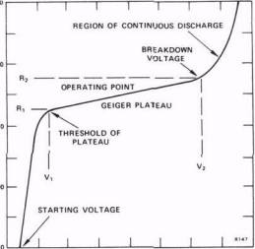
One of the main disadvantages of a Geiger Mueller detector is that the detector has a large dead time. Dead time for a Geiger counter is the measure of time from an initial pulse to when another pulse, disregarding of pulse height, is discharged. Figure 1.3 illustrates dead time and two other quantities of interest: recovery time and resolving time.

Figure 1.3: Dead Time and Recovery Time
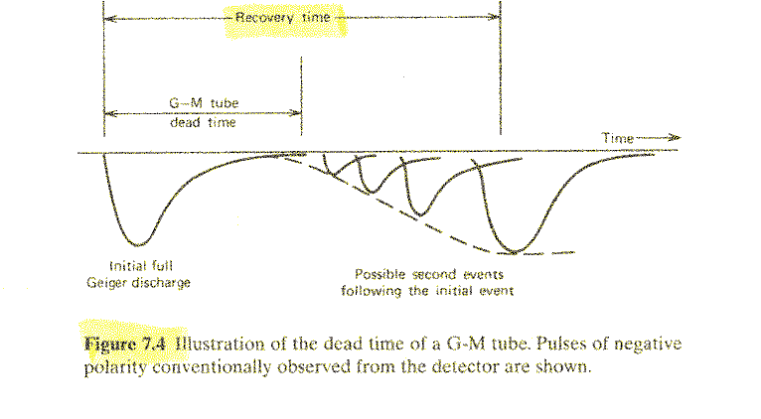

Recovery time is longer than dead time and is the elapsed time that occurs from when the detector can discharge a pulse of equal amplitude to the initial full pulse height. Recovery time is a little longer than dead time and is the time that the detector can read certain pulse height. Dead time can be calculated by either the two-source method or decaying source method. For this experiment, the dead time will be calculated by the two-source method. The two-source method involves observing the count rate of two sources independently and together to yield a value. Actual calculating methods for two-source dead time will be covered in the results of this report.
Detector efficiency comes in two varieties. The first variety is absolute efficiency, which is the ratio of the number pulses recorded by the detector over the amount of radiation the source gives off. The second variety is called intrinsic efficiency and is the ratio of the number pulses recorded by the detector over the radiation the detector that passes through the detector. Equation 1.2 shows the equations for both absolute and intrinsic efficiency.
Equation 2.1:

Of interest in this laboratory is the absolute efficiency, a modified more numerical version of Equation 2.1 was used to calculate efficiency for this laboratory. Equation 2.2 shows this equation, where S is the source count and B is the background count. A(t) is the activity of the source after a time t. A(t) is the activity equation given in Equation 2.3.
Equation 2.2: $ε=\frac{S−B}{A(t)}$
Equation 2.3: $A(t)=A_{0}e^{−\text{ln}(2)\frac{t}{t_{\text{half}}}}$

- Experimental Setup

The experiment was performed March 9th, 2006 in the Radiation Detection Laboratory. Jonathan Frasch was the laboratory assistant for this group with Dr. Shoaib Usman directing. The experimental setup for the laboratory was the same as Laboratory 2. Figure 2.1 shows the setup for this experiment. First, the High Voltage Power Supply (HPVS, Canberra Model 3002) was attached by coaxial cable to the pre-amplifer (Canberra M2006 SN 01961854). Second the amplifer (Ortec Model 485) was attached to the pre-amplifier for power purposes. Third, the Geiger-Mueller detector (Northwood Model TDS 220 Model D-10-5) was attached to the pre-

Figure 2.1 Experimental Setup
Preamp
HV
Power
Counter
1234
Cesium 137 Source
Geiger-Mueller Detector
amplifier. The final component was a Cesium 137 source placed at the end of the detector as shown in the picture. For the two-source dead time calculation, the other source was placed on top of the first source, and the first source was replaced by the second source for individual count rates for each source.
The first part of the experiment was to determine the Geiger Counting Plateau. This occurred by finding the starting voltage of the detector where it first counts and then taking measurements in voltage intervals until the detector approached the continuous discharge region. The starting voltage was started at 1020 volts and measurements where taken at twenty volt intervals until 1300 volts. The duration of each time interval was three minutes. After 1300 volts, measurements were taken in fifty volt intervals until the detector took a spike in counting and it was determined the detector was reaching the continuous discharge region after 1775 volts.
The second part of the experiment was determining dead time by using the two-source method. In addition, the laboratory handout assumed that the dead time was modeled for the non – paralyzable model. Two five micro-curie cesium 137 sources were used for this dead time calculation. First, the high voltage was set to 1120 volts (100 volts above starting voltage). A five-minute background count was taken without any source. Then one of the cesium sources, S₁, was counted for five minutes. The other source, S₂, was placed on top of S₁and a cumulative count was obtained for both sources for five minutes. Finally, S₁ was removed and S₂ counts were taken for five minutes.

- Experimental Results

The Geiger counter plateau data yielded a graph equivalent to Figure 1.2. The plotted graph yielded from the experiment is shown in Figure 3.1. From the data, starting voltage, knee, plateau, and continuous discharge region is seen on this graph. The horizontal axis represents voltage and the vertical axis represents three-minute count associated with each voltage. Experimental data is found in Appendix A and has all count, voltage, and error information for each point.

Figure 3.1 Geiger Counter Plateau Voltage
Detector dead time was calculated by the two-source method as discussed in the introduction. Table 3.1 gives information on variables X, Y, and Z, net counts for Source 1 (S₁) and Source 2 (S₂), background counts (b), and combined source count total (S₁₂) normalized to one second by dividing by five and then by sixty. The total five minute counts for each source, combined sources, and background is given in the third row.

Table 3.1 Dead Time Calculation Parameters
X | Y | Z | Source 1 |  | Source 2 | Source 1 and 2 | Background (b)
9255.69 | 1671375 | 0.309428 | 104 |  | 93 | 179 | 2
Five Minute Total Count: |  |  | 31257 |  | 27897 | 53670 | 726
Operating Voltage: 1120 V
Dead Time |  | 936 E-06 seconds

Dead time is given in seconds. The equation for dead time is given in Equation 3.1. X, Y, and Z are calculated from Source 1, Source 2, Source 1 and 2, and Background. The equations for X, Y, and Z parameters are given by Equations 3.2.
Equation 3.1: $τ=\frac{X\left(1−\sqrt{1−Z}\right)}{Y}$
Equations 3.2: $\begin{aligned}X=S_{1}⋅S_{2}−b⋅S_{\text{12}} \\ Y=S_{1}⋅S_{2}\left(S_{\text{12}}+b\right)−b⋅S_{\text{12}}\left(S_{1}+S_{2}\right) \\ Z=\frac{Y\left(S_{1}+S_{2}−S_{\text{12}}−b\right)}{X^{2}}\end{aligned}$
Dead time was 936 microseconds. The calculated value is in excess to the book approximation of dead time. The Knoll book has dead time equal to 100 microseconds, but the experimental value is about ten fold that value. However, the Health Physics Society website indicates that dead time can be several hundred microseconds in length and dead time would increase with detector usage and with age.
The final calculation for the laboratory was a calculation of detector absolute efficiency. Equation 1.2 and 1.3 calculated detector efficiency. Efficiency was calculated for both Source 1 and Source 2 with background count subtracted. The data used was obtained from the dead time calculation. The source strength of both sources was five micro-curie and both sources were activated on January 2000. Activity at present day (March 2006) was calculated from the activation date and initial activity. Table 3.2 gives the efficiency results in percent for both sources. Data collected for efficiency was normalized to counts per second. Activity was converted from curies to becquerels by multiplying the curie number by 3.7 E+10 Bq per Ci.
A website gave a value of efficiency can be as low as 0.01%. This value is of similar magnitude for the given results of 0.074% for Source 1 and 0.066% for Source 2.

Table 3.2 Source Efficiency Data
Source 1 | Source 2 | Background | Initial Activity, A₀  (dis per sec) | Elapsed Time since A₀ | Half - life
104.19 | 92.99 | 2 | 1.85 E5 | 6.4 years | 30.07 years
Activity Present (dis per sec) |  | 1.60 E5
Efficiency with Source 1 |  | 0.074%
Efficiency with Source 2 |  | 0.066%

4.0 Discussion of Results
As mentioned, Figure 3.1 matches the Geiger Counter Plateau given in Figure 1.2. The importance of this plateau is that the detector will not work if the voltage is below the plateau and the detector will become inoperative (read zero pulses due to continuous discharge) if the voltage is set too high. The plateau provides a voltage range were the Geiger Mueller detector can operate effectively. At the plateau voltage, the detector creates discharges that are heavily multiplied and engulfs the entire anode wire. This results in uniform pulse amplitudes each time. These uniform pulse amplitudes do not have any energy information or use for radiation spectroscopy, so as a result the Geiger counter can only be used as a counter to detect if a radiation field is present or not. In both Geiger Plateau figures, the transition from starting voltage to plateau voltage is sharp and not linear. The reason for such a sharp transition is analogous to a quantum effect. The transition stage has a voltage that creates a strong enough electric field that can cause gas multiplication and collection instead of recombining as seen prior to the Plateau. However, if the voltage is increased too much, the detector reaches a continuous discharge region (Region VI in Figure 1.1). In this region, the detector is inoperative, since the detector is discharging continuously and therefore is not in pulse mode. The detector essentially detects a continuous pulse, which it outputs as no radiation. First the count rates would increase dramatically as shown in Figure 3.1, until it ‘pegs –out’. It pegs – out due to such a high-count rate that it detects the previously discussed continuous pulse and registers this as no radiation present. Operating in continuous discharge region will also damage the detector in addition to reading a higher count rate as it approaches the region or reads nothing when it actually reaches the region of continuous voltage. Damage to the physical detector would be to the anode, since it would weaken and perhaps break due to the high thermal energy from all the multiplication and discharges. In addition, there would be a maximization of quench gas consumption / depletion and this would over the long-term decrease detector lifetime. Finally, dead time would increase since it would take longer for the multiplication to stop and for the gases to recombine.
Dead time was calculated to be 936 microseconds, which was about ten fold higher than the book or two fold higher than the Health Physics Society value of a few hundred microseconds. One way to minimize large dead time is to have operating voltage as close to the Geiger Plateau region as possible. This is because at higher operating voltages, it takes longer for the fill and quench gases to recombine. This leads to a higher dead time, but count rate would be approximately the same. Equation 4.1 gives another dead time approximation. This dead time approximation assumes that background is approximately zero.
Equation 4.1: $τ=\frac{m_{1}m_{2}−[m_{1}m_{2}\left(m_{\text{12}}−m_{1}\right)\left(m_{\text{12}}−m_{2}\right)]^{\frac{1}{2}}}{m_{1}m_{2}m_{\text{12}}}$
In Equation 4.1, m₁ is Source 1, m₂ is Source 2, and m₁₂ is the summation of Source 1 and 2. Placing the values in Table 3.1 into Equation 4.1, the dead time is 1024 microseconds. The dead time calculated by Equation 4.1 is a little higher than that calculated by Equation 3.1. Relative error between the two measurements, assuming the 936 microsecond dead time as being the actual value is given by equation 4.2. Relative error between the dead times is 9.4%.
Equation 4.2: ${\text{Error}}_{\text{Re}\text{lative}}=\frac{\text{Observed}−\text{Actual}}{\text{Actual}}x\text{100}\text{\%}$
Since the dead time is above several hundred microseconds (several equals four), fractional dead time can be used to determine if the sources were active enough to obtain a value of greater than 20 percent. Fractional dead time is found in Equation 4.3. Where τ is the dead time calculated
Equation 4.3: $τ=s_{\text{12}}τ$
from Equation 3.1 and s₁₂ is the combined source counts found in Table 3.1. The fractional dead time is 16.75 percent. This will not achieve the best results for calculating dead time, and thus a reason for the higher than expected dead time is that the sources used were not active enough.

System efficiency calculations were above the given lower range of 0.01%. Therefore, more confidence can be given to that calculation. Many factors affect system efficiency. Most of these factors are geometry factors. The difference between system efficiency between the two sources could be a geometry, anomaly, or materials issue. The sources could have been placed at locations slightly further or closer to the detector since no system was used to make sure the source was placed at the same exact distance away from the detector. In addition, the background count could have been higher due to some anomalous reason (cosmic radiation, etc.) during the different counts. Finally, the sources could have actually had a slightly different activity, since manufacturing an exact five-microcurie source would be near impossible.

5.0 Conclusions
Overall, radiation detection book theory was proved a correct model for observed data, especially the Geiger Plateau. The Geiger Plateau, dead time, and detector efficiency were all calculated for this laboratory. It was observed that the Geiger Plateau experimental graph matches the theory given in the Knoll textbook. Dead time was found to be higher than the suggested Knoll value, however since fractional dead time was below twenty percent. Because of the dead time being lower than twenty percent, it can be concluded that the five-microcurie sources were not strong enough to be used for an effective dead time calculation. System efficiency was found to be in the lower range of 0.01% found by internet searches.
Overall, the experiment occurred without major delay or ambiguous directions. In addition, the experiment presented the experimenters with useful calculations, showed relevant concepts, and verification of theory lectured on. The only suggestion would be to calculate dead time and system efficiency for an ion chamber or proportional counter as well as a Geiger Mueller. The purpose of that would be to compare various detectors to have a better understanding of detector properties.

- Reference

Chapter 10: Radiation Detection and Measurement. University of Rhode Island Radiation Safety

Office. Internet. November 19, 2004. http://www.uri.edu/radiation/.

DOE Fundamentals Handbook: Instrumentation and Control Volume 2. Department of Energy

Internet. 1992. http://www.eh.doe.gov/techstds/standard /hdbk1013/h1013v2.pdf.

Geiger Counting: Physics 352 Modern Physics Laboratory. Internet.

http://physics.indstate.edu/swez/MPLab/MPL%20Add/exp1/Exp1_files/image002.jpg.

Health Physics Society: Public and Media Information. Internet. February 25, 2005.

http://www.hps.org/publicinformation/.

Knoll, Glen F. Radiation Detection and Measurement. John Wiley & Sons, Hoboken NJ, 2000.

Appendix A: Raw Data

Appendix A has all the raw data collected for the Geiger Counter Plateau Region.

VOLTAGE | COUNTS | σ
1020 | 9 | 3.00
1040 | 210 | 14.49
1060 | 586 | 24.21
1080 | 689 | 26.25
1100 | 602 | 24.54
1120 | 590 | 24.29
1140 | 568 | 23.83
1160 | 614 | 24.78
1180 | 576 | 24.00
1200 | 572 | 23.92
1220 | 608 | 24.66
1240 | 550 | 23.45
1260 | 621 | 24.92
1280 | 631 | 25.12
1300 | 615 | 24.80
1350 | 590 | 24.29
1400 | 543 | 23.30
1450 | 595 | 24.39
1500 | 675 | 25.98
1550 | 651 | 25.51
1600 | 654 | 25.57
1650 | 562 | 23.71
1700 | 668 | 25.85
1750 | 3222 | 56.76
1775 | 9387 | 96.89

Each voltage and corresponding count was considered as a single measurement. It is assumed that the standard deviation is given in Equation A.1. ‘X’ is the counts measured by the detector
Equation A.1: $σ=\sqrt{x}$
in three minutes. This approximation can be used since x represents only the number of successes. This success refers to pulses created by the radiation in the detector as opposed to radiation that escaped detector.

Chapter 10: Radiation Detection and Measurement found at http://www.uri.edu/radiation/Chapter%2010.pdf.

